Федеральное государственное автономное образовательное учреждение высшего образования «Национальный исследовательский университет «Московский институт электронной техники»

**Лабораторная работа**

**«Решение системы линейных уравнений»**

Работу выполнил

Учащийся группы ПИН-33

Карпеченков Михаил Владимирович

Под руководством

Васекина Бориса Васильевича

**Москва 2023**

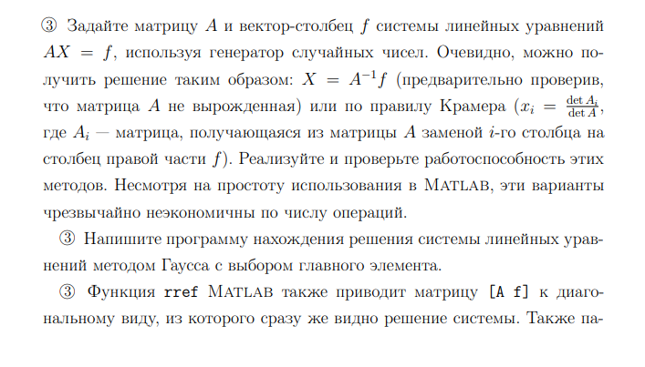

clear; clc;

n=5;

limit=20;

A=randi(limit,n)

B=randi(limit,n,1)

%inverse matrix method

if det(A)~=0

X=inv(A)*B

end

%Kramer's method

for i=1:n

A_i=A;

A_i(:,i)=B;

X(i)=det(A_i)/det(A);

end

X

A =

1 8 16 14 6

2 4 10 17 13

19 3 10 14 15

11 8 3 20 10

8 7 18 20 17

B =

4

3

1

4

11

X =

-0.729375215740421

5.011434242319640

-0.892043493268898

-2.927036589575422

3.314851570590264

X =

-0.729375215740421

5.011434242319639

-0.892043493268899

-2.927036589575422

3.314851570590265



function X=doGaussMethod(A,B)

l=length(B);

Aa=[A B];

for i=1:1:l

max=0;

maxId=0;

for j = i:1:l

if abs(Aa(j,i))>abs(max)

max=Aa(j,i);

maxId=j;

end

end

c=Aa(i,:);

Aa(i,:)=Aa(maxId,:);

Aa(maxId,:)=c;

Aa=Aa./max;

for j=i+1:1:l

Aa(j,:)=Aa(j,:)-Aa(j,i)*Aa(i,:)/Aa(i,i);

Aa(j,i)=0;

end

end

Aa=Aa./Aa(l,l);

X=ones(l,1);

X(l)=Aa(l,l+1);

for i=1:l-1

Aa(:,l-i+1)=Aa(:,l-i+1)*X(l-i+1);

s=sum(Aa(l-i,:))-2*Aa(l-i,l+1)-Aa(l-i,l-i);

X(l-i)=-s/Aa(l-i,l-i);

end

end

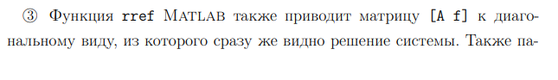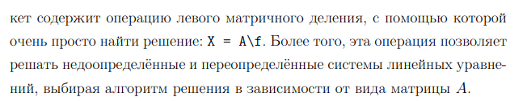

clear; clc;

n=5;

limit=20;

A=randi(limit,n)

B=randi(limit,n,1)

X1=doGaussMethod(A,B)

%checking

X2=inv(A)*B

rr=rref([A B])

X3=rr(:,length(A)+1)

X1 =

0.786824591259952

4.120950586519175

0.263986810915943

-4.841993101562024

0.233129976296116

X2 =

0.786824591259953

4.120950586519175

0.263986810915942

-4.841993101562025

0.233129976296116

rr =

1.000000000000000 0 0 0 0 0.786821705426357

0 1.000000000000000 0 0 0 4.120950323974082

0 0 1.000000000000000 0 0 0.264000000000000

0 0 0 1.000000000000000 0 -4.841991341991342

0 0 0 0 1.000000000000000 0.233128834355828

X3 =

0.786821705426357

4.120950323974082

0.264000000000000

-4.841991341991342

0.233128834355828

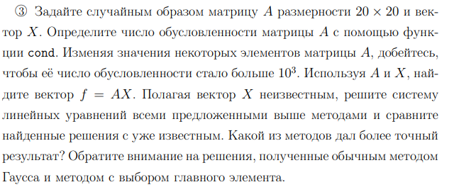

clear; clc;

n=20;

MAX=100;

A=randi(MAX,n);

X_old=randi(MAX,n,1)

X_new=X_old;

cond=cond(A)

XX=repmat(X_new',n,1);

B=sum(A.*XX,2);

if det(A)~=0

%reverse matrix method

disp("reverse matrix method:")

X_new=inv(A)*B

abs(X_new-X_old)

end

%Kramer's method

disp("Kramer's method:")

for i=1:n

A_i=A;

A_i(:,i)=B;

X_new(i)=det(A_i)/det(A);

end

X_new

abs(X_new-X_old)

%Gauss method with selection of the main element

disp("Gauss method with selection of the main element:")

X_new=doGaussMethod(A,B)

abs(X_new - X_old)

% X = A \ B

disp("X = A \ B")

X_new = A \ B

abs(X_new - X_old)

%rref

disp("rref:")

rr=rref([A B])

X_new=rr(:,length(A)+1)

abs(X_new - X_old)

X_old =

944

800

438

91

934

379

759

804

805

596

325

749

477

516

481

425

177

281

878

874

cond =

2.554507214621228e+03

reverse matrix method:

X_new =

1.0e+02 *

9.439999999999941

8.000000000000016

4.380000000000011

0.910000000000022

9.340000000000039

3.790000000000109

7.590000000000000

8.039999999999745

8.049999999999523

5.959999999999939

3.249999999999545

7.490000000000508

4.769999999999579

5.160000000000223

4.809999999999917

4.250000000001267

1.769999999999837

2.809999999999886

8.780000000000053

8.739999999999963

ans =

1.0e-09 *

0.005911715561524

0.001591615728103

0.001023181539495

0.002202682480856

0.003979039320257

0.010913936421275

0

0.025465851649642

0.047634785005357

0.006139089236967

0.045531578507507

0.050818016461562

0.042177816794720

0.022282620193437

0.008299139153678

0.126760824059602

0.016342482922482

0.011368683772162

0.005343281372916

0.003637978807092

Kramer's method:

X_new =

1.0e+02 *

9.439999999999523

7.999999999999755

4.379999999999762

0.909999999999957

9.339999999999916

3.789999999999885

7.589999999999807

8.039999999999726

8.049999999999335

5.959999999999996

3.250000000000331

7.489999999999612

4.769999999999872

5.160000000000207

4.809999999999971

4.250000000000030

1.769999999999925

2.809999999999959

8.780000000000099

8.739999999999938

ans =

1.0e-10 *

0.476347850053571

0.245563569478691

0.238173925026786

0.043200998334214

0.084128259913996

0.114823706098832

0.193267624126747

0.273985278909095

0.665068000671454

0.003410605131648

0.331397131958511

0.387672116630711

0.128466126625426

0.206910044653341

0.028421709430404

0.030127011996228

0.075033312896267

0.040927261579782

0.098907548817806

0.062527760746889

Gauss method with selection of the main element:

X_new =

1.0e+02 *

9.440000000000065

7.999999999999971

4.379999999999840

0.909999999999990

9.340000000000373

3.789999999999805

7.590000000000117

8.040000000000221

8.049999999999727

5.960000000000054

3.250000000000410

7.489999999999521

4.769999999999723

5.160000000000658

4.809999999999439

4.249999999999532

1.770000000000216

2.810000000000081

8.780000000000065

8.739999999999975

ans =

1.0e-10 *

0.065938365878537

0.029558577807620

0.160298441187479

0.009947598300641

0.372892827726901

0.194972926692571

0.117097442853265

0.220552465179935

0.272848410531878

0.054569682106376

0.409841049986426

0.478621586808003

0.276827449852135

0.658246790408157

0.560476109967567

0.468389771413058

0.216289208765374

0.081286088970955

0.064801497501321

0.025011104298756

X = A \ B

X_new =

1.0e+02 *

9.440000000000000

8.000000000000002

4.380000000000051

0.910000000000021

9.339999999999939

3.790000000000013

7.590000000000011

8.039999999999935

8.050000000000026

5.959999999999997

3.249999999999941

7.490000000000075

4.770000000000029

5.159999999999925

4.810000000000040

4.250000000000067

1.769999999999960

2.809999999999970

8.780000000000047

8.739999999999982

ans =

1.0e-11 *

0.011368683772162

0.022737367544323

0.505906427861191

0.207478478841949

0.602540239924565

0.130739863379858

0.102318153949454

0.648014975013211

0.250111042987555

0.022737367544323

0.591171556152403

0.750333128962666

0.289901436190121

0.750333128962666

0.392219590139575

0.665068000671454

0.403588273911737

0.301270119962282

0.477484718430787

0.181898940354586

rref:

rr =

Columns 1 through 17

1 0 0 0 0 0 0 0 0 0 0 0 0 0 0 0 0

0 1 0 0 0 0 0 0 0 0 0 0 0 0 0 0 0

0 0 1 0 0 0 0 0 0 0 0 0 0 0 0 0 0

0 0 0 1 0 0 0 0 0 0 0 0 0 0 0 0 0

0 0 0 0 1 0 0 0 0 0 0 0 0 0 0 0 0

0 0 0 0 0 1 0 0 0 0 0 0 0 0 0 0 0

0 0 0 0 0 0 1 0 0 0 0 0 0 0 0 0 0

0 0 0 0 0 0 0 1 0 0 0 0 0 0 0 0 0

0 0 0 0 0 0 0 0 1 0 0 0 0 0 0 0 0

0 0 0 0 0 0 0 0 0 1 0 0 0 0 0 0 0

0 0 0 0 0 0 0 0 0 0 1 0 0 0 0 0 0

0 0 0 0 0 0 0 0 0 0 0 1 0 0 0 0 0

0 0 0 0 0 0 0 0 0 0 0 0 1 0 0 0 0

0 0 0 0 0 0 0 0 0 0 0 0 0 1 0 0 0

0 0 0 0 0 0 0 0 0 0 0 0 0 0 1 0 0

0 0 0 0 0 0 0 0 0 0 0 0 0 0 0 1 0

0 0 0 0 0 0 0 0 0 0 0 0 0 0 0 0 1

0 0 0 0 0 0 0 0 0 0 0 0 0 0 0 0 0

0 0 0 0 0 0 0 0 0 0 0 0 0 0 0 0 0

0 0 0 0 0 0 0 0 0 0 0 0 0 0 0 0 0

Columns 18 through 21

0 0 0 944

0 0 0 800

0 0 0 438

0 0 0 91

0 0 0 934

0 0 0 379

0 0 0 759

0 0 0 804

0 0 0 805

0 0 0 596

0 0 0 325

0 0 0 749

0 0 0 477

0 0 0 516

0 0 0 481

0 0 0 425

0 0 0 177

1 0 0 281

0 1 0 878

0 0 1 874

X_new =

944

800

438

91

934

379

759

804

805

596

325

749

477

516

481

425

177

281

878

874

ans =

0

0

0

0

0

0

0

0

0

0

0

0

0

0

0

0

0

0

0

0